# ARTICLES THAT DO NOT COMPLY WITH THE FORMAT AND REGULATIONS WILL BE REJECTED IMMEDIATELY.

# Article Title (Initial Caps Only, Calibri 14)

Fourth Author's Full Name

<https://orcid.org/0000-0003-2X67-5377>

correo@institucion.com

Name of University or place of work

City, Country

Third Author's Full Name

<https://orcid.org/0000-0003-2X67-5377>

correo@institucion.com

Name of University or place of work

City, Country

Second Author’s Full Name

<https://orcid.org/0000-0003-XV67-2607>

correo@institucion.com

Name of University or place of work

City, Country

First Author’s Full Name

<https://orcid.org/0000-0003-2X67-5377>

correo@institucion.com

Name of University or place of work

City, Country

#### Abstract. - (maximum 150 words) Everything must be written in a single paragraph; only consecutive periods are allowed. It must include the objectives, methodology used, results, and conclusions in writing. The full article must have a maximum length of 12 pages. The letter must be Calibri in size N°11. With a single space of 1.15. Maximum 15 references.

#### Keywords: 3 to 4 keywords separated by comma (,)

**Spanish Title (Size 12)**

#### Resumen: (less than 150 words)

#### Palabras clave: 3-4 Keywords

## INTRODUCTION

### It must state the problem precisely and the general objective and indicate the basis of the study or research project and the methodology used for its presentation. It is recommended to follow the scheme adopted in the Universidad Ciencia y Tecnologia Journal: introduction, development (methodology, results, and discussion), conclusions, and bibliographic references. Provide bibliographical support to the research with a brief review of the state of the art, citing the references related to the topic in an orderly way. To close the section, explain the article's organization or structure concisely. Remember that the complete article should be a maximum length of 12 pages. Avoid using verbatim quotes.

## DEVELOPMENT

Text in **Calibri** size 11

### *Subtitles (*Uppercase only) Do not increase indentation)

Text in **Calibri** size 11

## METHODOLOGY

Text in **Calibri** size 11. It does not carry citations or definitions

### *Subtitles (*Uppercase only) Do not increase indentation)

Text in **Calibri** size 11

## RESULTS

Text in **Calibri** size 11. Consider the standards for tables and figures described in this document for this section.

### *Subtitles (*Uppercase only) Do not increase indentation)

## CONCLUSIONS (Does not have Roman numerals)

Text in **Calibri** size 11

### *Subtitles (*Uppercase only) Do not increase indentation)

Avoid reproducing the aspects contained in the summary as a conclusion. *The conclusions presented should be relevant only to the contribution made*. If you prefer, you can use numbering.

A conclusion could extend the importance of the work, or it could make you think about apps and extensions.

## APPENDIX (Optional)

Appendices, if necessary, appear before the examination.

RECOGNITION (Optional)

Use the singular title even when you have a lot of recognition. Avoid expressions such as "One of us (S.B.A.) would like to thank...." Instead, write "F. A. Author's Acknowledgments...." **Acknowledgments to sponsors and financial support are in the unnumbered footnote on the first page.**

REFERENCES (Centered and numbered)

**Citations and references must be made with IEEE STANDARDS.**

**Maximum 15 citations and references.**

**GENERAL PROVISIONS:**

#### The full article must have a maximum length of 12 pages and a minimum of 10 pages.

* The equations must be performed in the Word editor and must be listed in sequential order. Example:

$A=πr^{2}$ (1)

$x=\frac{-b±\sqrt{b^{2}-4ac}}{2a}$ (2)

* The digits will have a comma for decimal placement.
* All images will be processed as figures. **Don't include figures from the internet** but only those results from your research. The title should be at the bottom. **The reference should be in the text before the figure**. Figures must be vectorized. They should not be taken from the internet. Figures corresponding to the results must be in the original Excel format.



Fig. 1. Library.

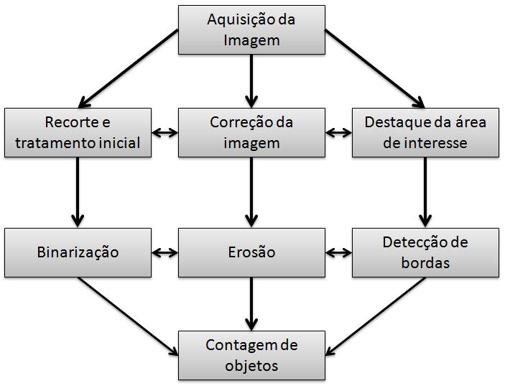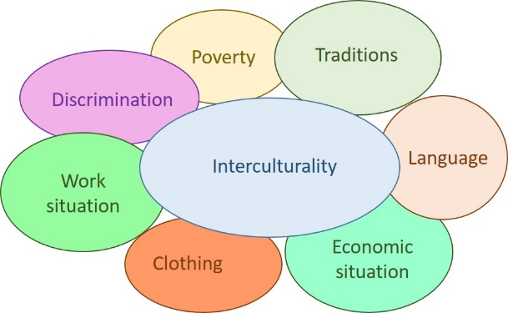

1. (b)

Fig. 5. (a) Operating Diagram, (b) Interculturality Diagram

Declare the subheadings of the figures below them; Place the table titles at the top. If your shape has two parts, include the labels "(a)" and "(b)" as part of each section.

* Figure axis labels are often confused. For this reason, use words instead of symbols.
* Write preferably in the third person and with technical-scientific language.
* For tables, consider that they should all be useful for research. Place the table titles at the top. Do not place captions in "text boxes" or insert them into the figure. Do not put outer edges on them. Do not abbreviate "Table"; the tables are numbered with Arabic numerals (1, 2, 3, 4, …, etc.). Figure axis labels are confused. Use words instead of symbols.

Table 1. Comparison of results obtained. (Font size 10 for figure and table titles)

|  |  |  |
| --- | --- | --- |
| Title | Title | Title |
| Theme | 0,55 | 45% |
| Theme | 0,68 | 5% |
| Theme | 1,25 | 50% |

Tables should be strictly in this format.

* At the end of the article, after the references, include a brief description of the authors, a maximum of 4 lines, and a photo of the article.

THE AUTHORS:

**Albert Einstein**, a [German](https://es.wikipedia.org/wiki/Imperio_alem%C3%A1n) physicist of [Jewish](https://es.wikipedia.org/wiki/Pueblo_jud%C3%ADo) origin, later naturalized [Swiss](https://es.wikipedia.org/wiki/Suiza), [Austrian](https://es.wikipedia.org/wiki/Austria), and [American](https://es.wikipedia.org/wiki/Nacionalidad_estadounidense). He is considered the most important, well-known scientist of the 20th century.

Maximum five lines describing it: The photo must be high resolution and have no margins, borders, or design effects.

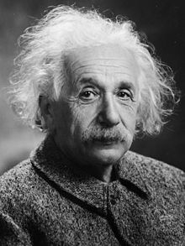

IEEE CITATION AND REFERRAL PROCEDURES

Number citations consecutively in square brackets [1]. The period of the sentence follows the square brackets [2]. Multiple references [2] and [3] are numbered with separate brackets [1]–[3]. When quoting a section in a book, please indicate the relevant page numbers [2]. In sentences, refer to the reference number, as in [3]. Do not use "Ref. [3]" or "reference [3]" except at the beginning of a sentence: "Reference [3] shows..."

Please note that the references below follow the preferred style. You should cite all authors; do not use "the" unless there are six or more authors. Use a space after the author's initials. Documents that have not been published should be cited as "unpublished" [4]. Papers submitted or accepted for publication should be cited as "submitted for publication" [5]. Please indicate affiliations and addresses for personal communications [6].

More than 50% of citations must correspond to scientific articles indexed in Scopus and should contain the DOI.

Please note that:

1. References should be numbered in the order in which they appear in the document
2. Once a number has been assigned to a given reference, the same number should be used on all occasions when that document is cited in the text
3. Each reference number should be enclosed in square brackets [ ], for example, "... the end of the investigation [12]..."
4. It is not necessary to mention the author in the reference unless it is relevant in the text itself.
5. The body of the document will also not mention the date of publication
6. It is not necessary to include the word "reference", for example, "... in reference [27] ...": it is sufficient to indicate "... in [27]..."
7. To cite more than one source at a time, it is preferable to list each source with its square brackets, e.g., "as indicated by several studies [1], [3], [5]..." instead of "as indicated by various studies [1, 3, 5]..."
8. [1], [2],[3], [4], [5] not done [1]-[5], Rivera [1]-[3], [6]-[8]

Example:

**Books**

[citation number] Initial of the first name, Last name. Title of the book in italics. Edition. City. Editorial. Year

* [1] R. G. Gallager. *Principles of Digital Communication*. New York: Cambridge University Press, 2008.
* [2] A. Rezi and M. Allam, "Techniques in array processing employing transformations," in Control and Dynamic Systems, Vol. 69, Multidimensional Systems, C. T. Leondes, Ed. San Diego: Academic Press, 1995, pp. 133-180.
* [3] J. A Prufrock, Ed., Lasers, 2nd. ed. New York: McGraw-Hill, 2004.

**Journal article**

Author's initials and surname, "Title of the article in quotation marks", Abbreviated title of the journal in italics, volume (abbreviated vol.), abbreviated number (n°) pages (abbreviated pp.), Month Year.

[citation number] Initial of the first name, Last name. "Article title in quotation marks." Name of the journal abbreviated and italicized, volume (vol), number (n°), pages (pp), month Year.

Examples

* [4] G. Liu, K. Y. Lee, and H. F. Jordan, "TDM and TWDM de Brujin networks and suppleness for optical communications," IEEE Transactions on Computers, vol. 46, pp. 695-701, June 1997.
* [5] S.-Y. Chung, "Multi-level dirty paper coding," IEEE Communication Letters, vol. 12, no. 6, pp. 456-458, June 2008.

NOTE: To refer to articles that have not yet been accepted for publication, use the phrase "submitted for publication" instead of the date. If papers are accepted but not published yet, use "pending publication" instead of the date.

**Articles published at conferences**

[citation no] Initial of the first name, Last name. "Article Title" in Conference Name, City, State/Province, Year, Pages.

Examples

* [6] N. Osifchin and G. Vau, "Power considerations for the modernization of telecommunications in Central and Eastern European and former Soviet Union (CEE/FSU) countries", in Second International Telecommunications Energy Special Conference, 1997, pp. 9-16.
* [7] G. Caire, D. Burshtein, and S. Shamai (Shitz), "LDPC coding for interference mitigation at the transmitter," in Proceedings of the 40th Annual Allerton Conference in Communications, Control, and Computing, Monticello, IL, pp. 217-226, October 2002.

NOTE: The word "in" before the conference title is not italicized.

**Paper presented at the conference but not published**

[Citation number] Initial of the first name, Last name. "Conference title". Presented in Conference Name. City, Country, Year.

Example:

* [8] H. A. Nimr, "Defuzzification of the outputs of fuzzy controllers," presented at the 5th International Conference on Fuzzy Systems, Cairo, Egypt, 1996.

**Technical Reports (Reports, Internal Documents, Memorandum)**

[Citation number] Initial of the first name, Last name. "Title of the document." Company Name, Headquarters, Report Type, Report Number, Year of Publication.

Example:

* [9] K. E. Elliot and C. M. Greene, "A local adaptive protocol," Argonne National Laboratory, Argonne, France, Tech. Rep. 916-1010-BB, 1997.

**Master's thesis or doctoral thesis**

[Citation number] Initial of the name, Author's surname, "Title of the thesis or project", Type of document (doctoral thesis, master's thesis, etc.), Department, Academic institution (abbreviated), City, Abbreviated State, Year.

Example:

* [10] H. Zhang, "Delay-insensitive networks," M.S. thesis, University of Waterloo, Waterloo, ON, Canada, 1997.
* [11] J.-C. Wu. "Rate-distortion analysis and digital transmission of nonstationary images". Ph.D. dissertation, Rutgers, the State University of New Jersey, Piscataway, NJ, USA, 1998.

**Lecture Notes**

[Citation number] "Title of the notes or subject," class notes for Subject Code, Department, Institution or University, time and year.

Example:

* [12] "Signal integrity and interconnects for high-speed applications," class notes for ECE497-JS, Department of Electrical and Computer Engineering, University of Illinois at Urbana-Champaign, Winter 1997.

**Private Communications**

[Citation number] Initial of the name, Surname of the person with whom the communication is maintained (private communication), Year.

Example:

* [13] T. I. Wein (private communication), 1997.

**From the internet**

[Citation number] Initial of the name, Author's surname (year, month, and day). Title (edition) [Type of media, usually Online]. Available in: Full URL

Example:

* [14] J. Jones. (1991, May 10). Networks (2nd ed.) [Online]. Available: http://www.atm.com

NOTE: Internet resources can be very varied (journals, monographs, entity websites, databases, etc.) In general, they are cited as the printed document of the type to which they belong with the addition of the indication [Online] or another type of medium by which they are transmitted, and the DOI (Digital Object Identifier) or URL.

**Catalogues**

[Citation number] Catalog No. Catalog Code, Product Name, Company, City, State (abbreviated)

Example:

* [15] Catalog No. NWM-1, Microwave Components, M. W. Microwave Corp., Brooklyn, NY.

**Application Notes**

[Citation number] Product or Company Name, Appl. Note Application Note Number, Pages (abbreviated pp.)

Example:

* [16] Hewlett-Packard, Appl. Note 935, pp. 25-29.

**Standards or patents**

[Citation number] Author's initials and last name, "Patent Title", Number, Month, Day, Year.

Example:

* [17] K. Kimura and A. Lipeles, "Fuzzy Controller Component,"; U. S. Patent 14,860,040, December 14, 1996.

**Research Data**

[Citation number] Author's initials and surname, "Information title," City, Country, year.

[9] M. Veljić, N. Rajčević, and D. Bukvički, "A revision of the moss collection of the University of Belgrade Herbarium (beou) from the Ostrozub mountain in Serbia." Zenodo, 2016.