# 

# Book Title (Initial capital letters only, Garamond 16)

Example: University Physics

# Chapter Title (Initial capital letters only, Garamond 14)

Example: Kinematics (Chapter 2)

ISBN:

Edition: First, Second (as the case may be)

Editorial:

Publication Date:

Authors: Last Name, First Name, Last Name, First Name, Last Name, First Name, First Name, Last Name, First Name, Last Name, First

AUTHOR INFORMATION

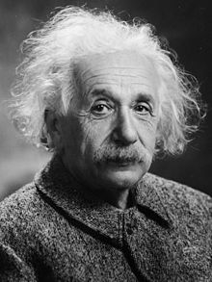

**Albert Einstein**, [German](https://es.wikipedia.org/wiki/Imperio_alem%C3%A1n) physicist of [Jewish](https://es.wikipedia.org/wiki/Pueblo_jud%C3%ADo) origin, later naturalized [Swiss](https://es.wikipedia.org/wiki/Suiza), [Austrian](https://es.wikipedia.org/wiki/Austria) and [American](https://es.wikipedia.org/wiki/Nacionalidad_estadounidense). He is considered the most important, well-known, and popular scientist of the [20th century](https://es.wikipedia.org/wiki/Siglo_XX).

ORCID:

Mail:

Institutional Affiliation:

CHAPTER TABLE OF CONTENTS (AUTHOR'S OPTIONAL)

PREFACE (OPTIONAL BY THE AUTHOR)

## INTRODUCTION

Include a brief introduction of the book chapter, briefly specify what the chapter is about, what chapter number it is, how many additional chapters there are, reason for the book's realization. The document must have a maximum length of 30 pages.

## DEVELOPMENT

Text in Garamond issue 11

### *Subtitles (*Uppercase only) Do not increase indentation)

BIBLIOGRAPHY (Centered)

In the text of the chapter, the names of persons, institutes, etc., may be mentioned without the need to cite them. You can place a super index and its corresponding footer if required.

Any material consulted may be included in the bibliography, even if it is not cited.

**GENERAL PROVISIONS:**

The chapter of the book should have a maximum of 35 pages, following the journal's format. Must have a maximum of 4 authors

Font size: 11.

Typeface: Garamond.

Spacing: 1.15.

Margins: left: 3cm; All others: 2cm

* All images will be processed, as shapes. Do not include figures copied from the internet, but those that are the product of your research. The title should be at the bottom. It would help if you referenced it in the text before the figure.



Figure 1. Library

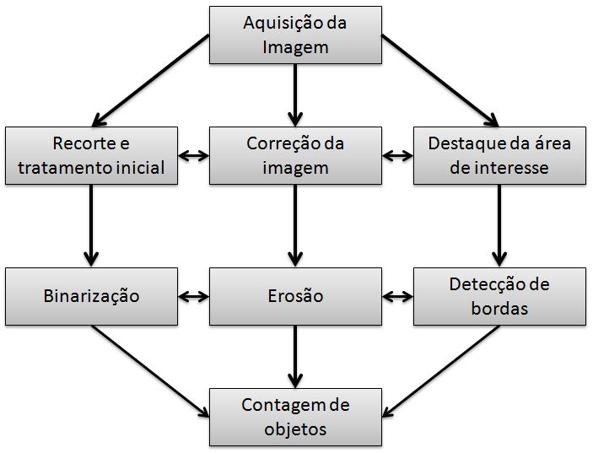

Figure 5. Operating Diagram

Declare the subheadings of the figures below them; Place the table titles at the top. If your shape has two parts, include the labels "(a)" and "(b)" as part of each section.

* Figure axis labels are often a source of confusion. Use words instead of symbols.
* Write preferably in the third person and with technical-scientific language.
* For tables, consider that they should all be useful for research. Place the table titles at the top. Do not place captions in "text boxes" or otherwise insert them into the figure. The tables are numbered with Roman numerals.
* Figure axis labels are often a source of confusion. Use words instead of symbols.

TABLE 1. Comparison of results obtained.

|  |  |  |  |
| --- | --- | --- | --- |
| Variable 1 | Variable 2 | Variable 3 | Variable 4 |
| Time(s) | 2,56 | 4,67 | 5,87 |
| Speed (m/s) | 123,30 | 120,72 | 120,91 |
| Height (m) | 25,01 | 35,12 | 45,02 |